**НАЦИОНАЛЬНЫЙ ИССЛЕДОВАТЕЛЬСКИЙ УНИВЕРСИТЕТ ИТМО**

**Факультет систем управления и робототехники**

**Программирование**

Лабораторная работа № 02

Вариант**:** 8729

**Выполнил студент:**

Нгуен Тхай Шон

**Группа:** R3135

**Преподаватель:** Гаврилов Антон Валерьевич

г. Санкт-Петербург

2020

***1. Задание:***

На основе базового класса Pokemon написать свои классы для заданных видов покемонов. Каждый вид покемона должен иметь один или два типа и стандартные базовые характеристики.

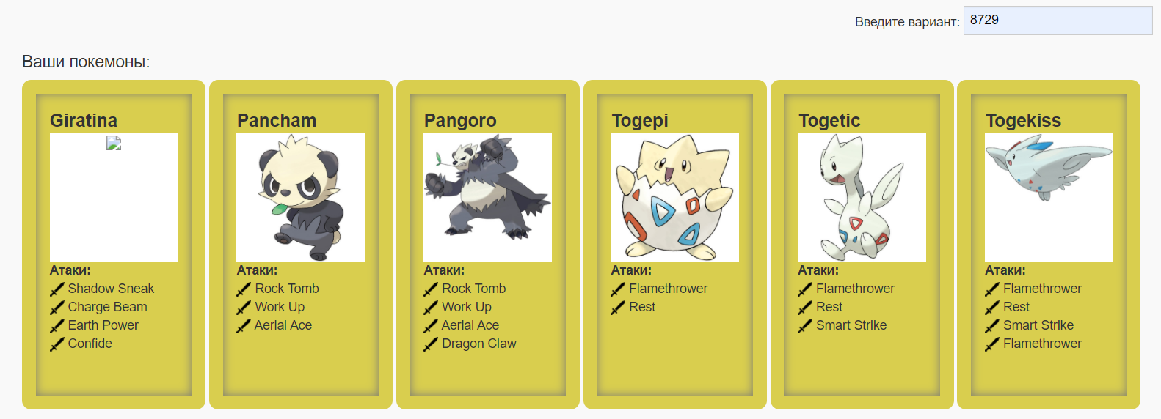

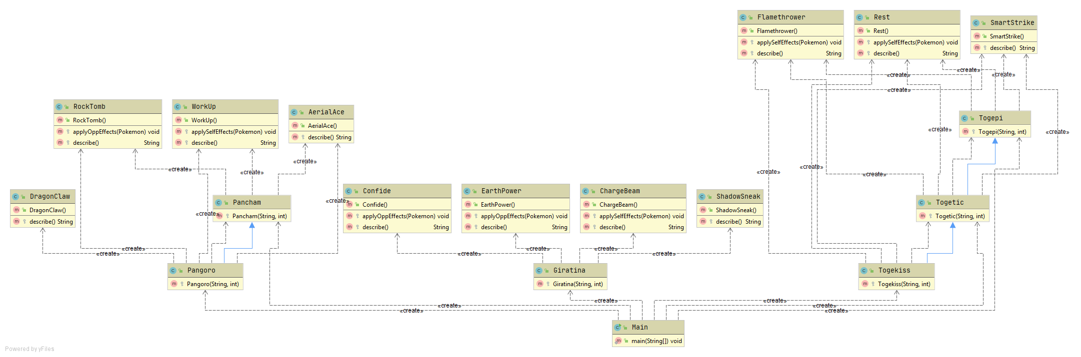***2. UML-диаграмма:***

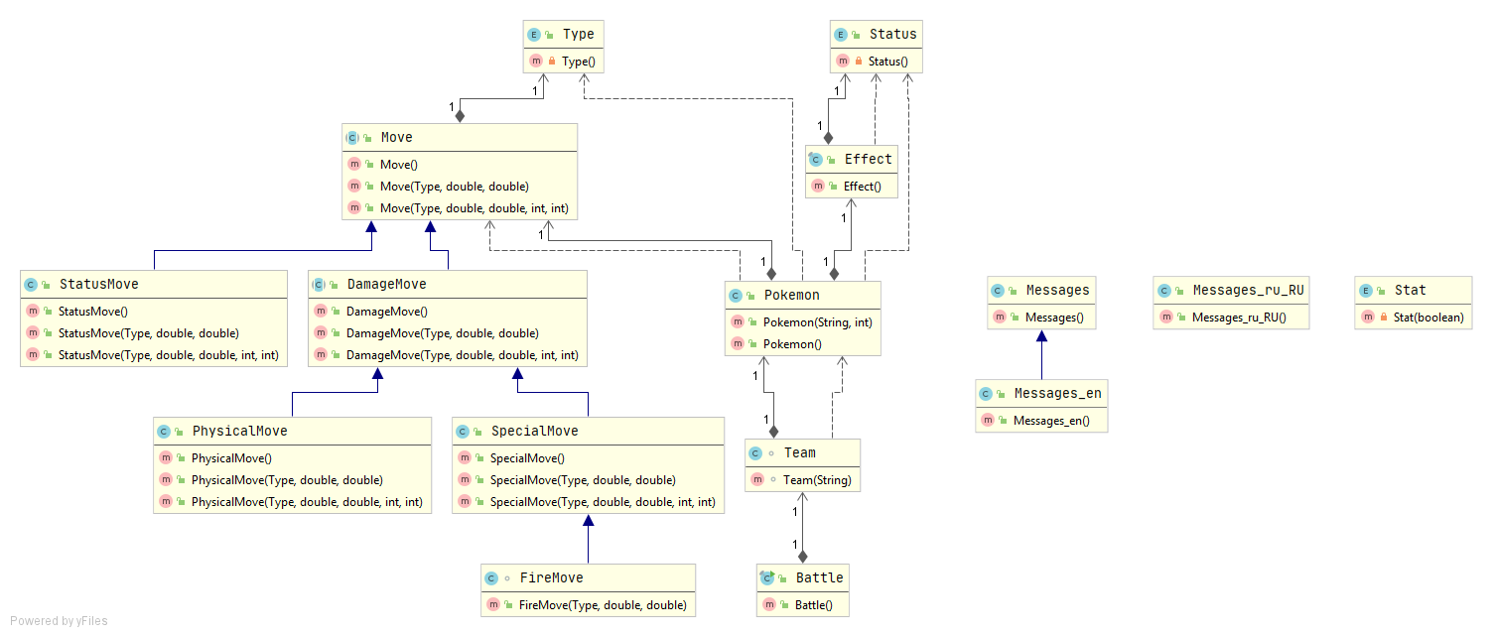

***3. Исходный код главного класса:***

|  |
| --- |
| **package Pokemons;**  **import** ru.ifmo.se.pokemon.*;  **public class** Main {  **public static void** main(String[] args) {  Battle b = **new** Battle();  b.addAlly(**new** Giratina(**"Torres"**, 1));  b.addAlly(**new** Pancham(**"Busquet"**, 1));  b.addAlly(**new** Pangoro(**"Casillas"**, 1));  b.addFoe(**new** Togekiss(**"Xavi"**, 1));  b.addFoe(**new** Togepi(**"Iniesta"**, 1));  b.addFoe(**new** Togetic(**"Fabregas"**, 1));  b.go();  } } |

***4. Исходные коды покемона:***

|  |  |
| --- | --- |
| **package** Pokemons;  **import** ru.ifmo.se.pokemon.*;  **public class** Giratina **extends** Pokemon{  **protected** Giratina(String name, **int** level){  **super**(name, level);  setType(Type.***GHOST***, Type.***DRAGON***);  setStats(150, 100, 120, 100, 120, 90);  addMove(**new** ShadowSneak());  addMove(**new** ChargeBeam());  addMove(**new** EarthPower());  addMove(**new** Confide());  } } | **package** Pokemons;  **import** ru.ifmo.se.pokemon.*;  **public class** Pancham **extends** Pokemon {  **protected** Pancham(String name, **int** level){  **super**(name, level);  setType(Type.***FIGHTING***);  setStats(67, 82, 62, 46, 48, 43);  addMove(**new** RockTomb());  addMove(**new** WorkUp());  addMove(**new** AerialAce());  } } |
| **package** Pokemons;  **import** ru.ifmo.se.pokemon.*;  **public class** Pangoro **extends** Pancham{  **protected** Pangoro(String name, **int** level){  **super**(name, level);  setType(Type.***FIGHTING***, Type.***DARK***);  setStats(95,124,78,69,71,58);  addMove(**new** RockTomb());  addMove(**new** WorkUp());  addMove(**new** AerialAce());  addMove(**new** DragonClaw());  } } | **package** Pokemons;  **import** ru.ifmo.se.pokemon.*;  **public class** Togepi **extends** Pokemon {  **protected** Togepi(String name, **int** level){  **super**(name, level);  setType(Type.***FAIRY***);  setStats(35,20,65,40,65,20);  addMove(**new** Flamethrower());  addMove(**new** Rest());  addMove(**new** SmartStrike());  } } |
| **package** Pokemons;  **import** ru.ifmo.se.pokemon.*;  **public class** Togetic **extends** Togepi{  **protected** Togetic(String name, **int** level){  **super**(name, level);  setType(Type.***FAIRY***, Type.***FLYING***);  setStats(55,40,85,80,105,40);  addMove(**new** Flamethrower());  addMove(**new** Rest());  addMove(**new** SmartStrike());  } } | **package** Pokemons;  **import** ru.ifmo.se.pokemon.*;  **public class** Togekiss **extends** Togetic {  **protected** Togekiss(String name, **int** level){  **super**(name, level);  setType(Type.***FAIRY***, Type.***FLYING***);  setStats(85,50,95,120,115,80);  addMove(**new** Flamethrower());  addMove(**new** Rest());  addMove(**new** SmartStrike());  addMove(**new** Flamethrower());  } } |

***5. Исходные коды атаки покемона:***

|  |
| --- |
| **package** Pokemons;  **import** ru.ifmo.se.pokemon.*;  **public class** DragonClaw **extends** PhysicalMove {  **protected** DragonClaw(){  **super**(Type.***DRAGON***, 80.0, 100.0);  }   **protected** String describe(){  **return "uses Dragon Claw"**;  } } |
| **package** Pokemons;  **import** ru.ifmo.se.pokemon.*;  **public class** RockTomb **extends** PhysicalMove{  **protected** RockTomb(){  **super**(Type.***ROCK***, 60.0, 95.0);  }   **protected void** applyOppEffects(Pokemon p){  Effect e = **new** Effect().chance(1).turns(-1).stat(Stat.***SPEED***, -1);  p.setCondition(e);  }  **protected** String describe(){  **return "uses Rock Tomb"**;  } } |
| **package** Pokemons;  **import** ru.ifmo.se.pokemon.*;  **public class** WorkUp **extends** PhysicalMove {  **protected** WorkUp(){  **super**(Type.***NORMAL***, 0.0, 100.0);  }   **protected void** applySelfEffects(Pokemon p){  Effect e = **new** Effect().chance(1).turns(-1).stat(Stat.***ATTACK***, +1).stat(Stat.***SPECIAL_ATTACK***, +1);  p.setCondition(e);  }   **protected** String describe(){  **return "uses Work Up"**;  } } |
| **package** Pokemons;  **import** ru.ifmo.se.pokemon.*;  **public class** AerialAce **extends** PhysicalMove {  **protected** AerialAce(){  **super**(Type.***FLYING***, 60.0, 100.0);  }   **protected** String describe(){  **return "Uses Aerial Ace"**;  } } |
| **package** Pokemons;  **import** ru.ifmo.se.pokemon.*;  **public class** Confide **extends** StatusMove{  **protected** Confide(){  **super**(Type.***NORMAL***, 0.0, 100.0);  }   **protected void** applyOppEffects(Pokemon p){  Effect e = **new** Effect().chance(1).turns(-1).stat(Stat.***SPECIAL_ATTACK***, -1);  p.setCondition(e);  }  **protected** String describe(){  **return "uses Confide"**;  } } |
| **package** Pokemons;  **import** ru.ifmo.se.pokemon.*;  **public class** EarthPower **extends** SpecialMove {  **protected** EarthPower(){  **super**(Type.***GROUND***, 90.0, 100.0);  }   **protected void** applyOppEffects(Pokemon p){  Effect e = **new** Effect().chance(0.1).turns(-1).stat(Stat.***SPECIAL_DEFENSE***, -1);  p.setCondition(e);  }  **protected** String describe(){  **return "uses Earth Power"**;  } } |
| **package** Pokemons;  **import** ru.ifmo.se.pokemon.*;  **public class** ChargeBeam **extends** SpecialMove{  **protected** ChargeBeam(){  **super**(Type.***ELECTRIC***, 50.0, 90.0);  }   **protected void** applySelfEffects(Pokemon p){  Effect e = **new** Effect().chance(0.7).turns(-1).stat(Stat.***SPECIAL_ATTACK***, +1);  p.setCondition(e);  }  **protected** String describe(){  **return "Uses Charge Beam"**;  } } |
| **package** Pokemons;  **import** ru.ifmo.se.pokemon.*;  **public class** ShadowSneak **extends** PhysicalMove {  **protected** ShadowSneak(){  **super**(Type.***GHOST***, 40.0, 100.0);  }   **protected** String describe(){ **return "uses Shadow Sneak"**; } } |
| **package** Pokemons;  **import** ru.ifmo.se.pokemon.*;  **public class** Flamethrower **extends** SpecialMove{  **protected** Flamethrower(){  **super**(Type.***FIRE***, 90.0, 100.0);  }   **protected void** applySelfEffects(Pokemon p){  **if** (Math.*random*() < 0.1)  Effect.*burn*(p);  }  **protected** String describe(){  **return "uses Flamethrower"**;  } } |
| **package** Pokemons;  **import** ru.ifmo.se.pokemon.*;  **public class** Rest **extends** StatusMove {  **protected** Rest(){  **super**(Type.***PSYCHIC***, 0.0, 100.0);  }   **protected void** applySelfEffects(Pokemon p){  p.restore();  Effect e = **new** Effect().turns(2).condition(Status.***SLEEP***);  p.setCondition(e);  }  **protected** String describe(){  **return "uses Rest"**;  } } |
| **package** Pokemons;  **import** ru.ifmo.se.pokemon.*;  **public class** SmartStrike **extends** PhysicalMove {  **protected** SmartStrike(){  **super**(Type.***STEEL***, 70.0, 100.0);  }   **protected** String describe(){  **return "uses Smart Strike"**;  } } |

***6. Результат программы:***

Giratina Torres from the team Yellow enters the battle!

Togekiss Xavi from the team Striped enters the battle!

Giratina Torres uses Confide.

Togekiss Xavi uses Flamethrower.

Giratina Torres loses 3 hit points.

Giratina Torres uses Earth Power.

Togekiss Xavi loses 1 hit points.

Togekiss Xavi isn't affected by GROUND

Togekiss Xavi uses Flamethrower.

Giratina Torres loses 3 hit points.

Giratina Torres uses Shadow Sneak.

Togekiss Xavi loses 7 hit points.

Togekiss Xavi uses Smart Strike.

Giratina Torres loses 4 hit points.

Giratina Torres Uses Charge Beam.

Togekiss Xavi loses 11 hit points.

Togekiss Xavi faints.

Togepi Iniesta from the team Striped enters the battle!

Giratina Torres uses Shadow Sneak.

Togepi Iniesta loses 7 hit points.

Togepi Iniesta uses Flamethrower.

Giratina Torres loses 2 hit points.

Giratina Torres uses Confide.

Togepi Iniesta uses Smart Strike.

Giratina Torres loses 5 hit points.

Giratina Torres faints.

Pancham Busquet from the team Yellow enters the battle!

Pancham Busquet Uses Aerial Ace.

Togepi Iniesta loses 5 hit points.

Togepi Iniesta faints.

Togetic Fabregas from the team Striped enters the battle!

Pancham Busquet uses Rock Tomb.

Togetic Fabregas loses 10 hit points.

Togetic Fabregas uses Rest.

Togetic Fabregas is sleeping

Pancham Busquet uses Rock Tomb.

Togetic Fabregas loses 7 hit points.

Togetic Fabregas

Togetic Fabregas uses Flamethrower.

Pancham Busquet loses 7 hit points.

Togetic Fabregas uses Rest.

Togetic Fabregas is sleeping

Pancham Busquet Uses Aerial Ace.

Togetic Fabregas loses 5 hit points.

Pancham Busquet struggles.

Togetic Fabregas loses 5 hit points.

Pancham Busquet loses 1 hit points.

Togetic Fabregas uses Smart Strike.

Pancham Busquet loses 5 hit points.

Pancham Busquet faints.

Pangoro Casillas from the team Yellow enters the battle!

Pangoro Casillas Uses Aerial Ace.

Togetic Fabregas loses 5 hit points.

Togetic Fabregas faints.

Team Striped loses its last Pokemon.

The team Yellow wins the battle!

***7. Вывод:***

Во времени выполнения лабораторной я на простом примере разобрался с основными концепциями ООП (объектно ориентированного программирования) в Java и научился написать программу, опираясь на полученные знания.